เลือก package ของ ROS2 : nav2_bringup
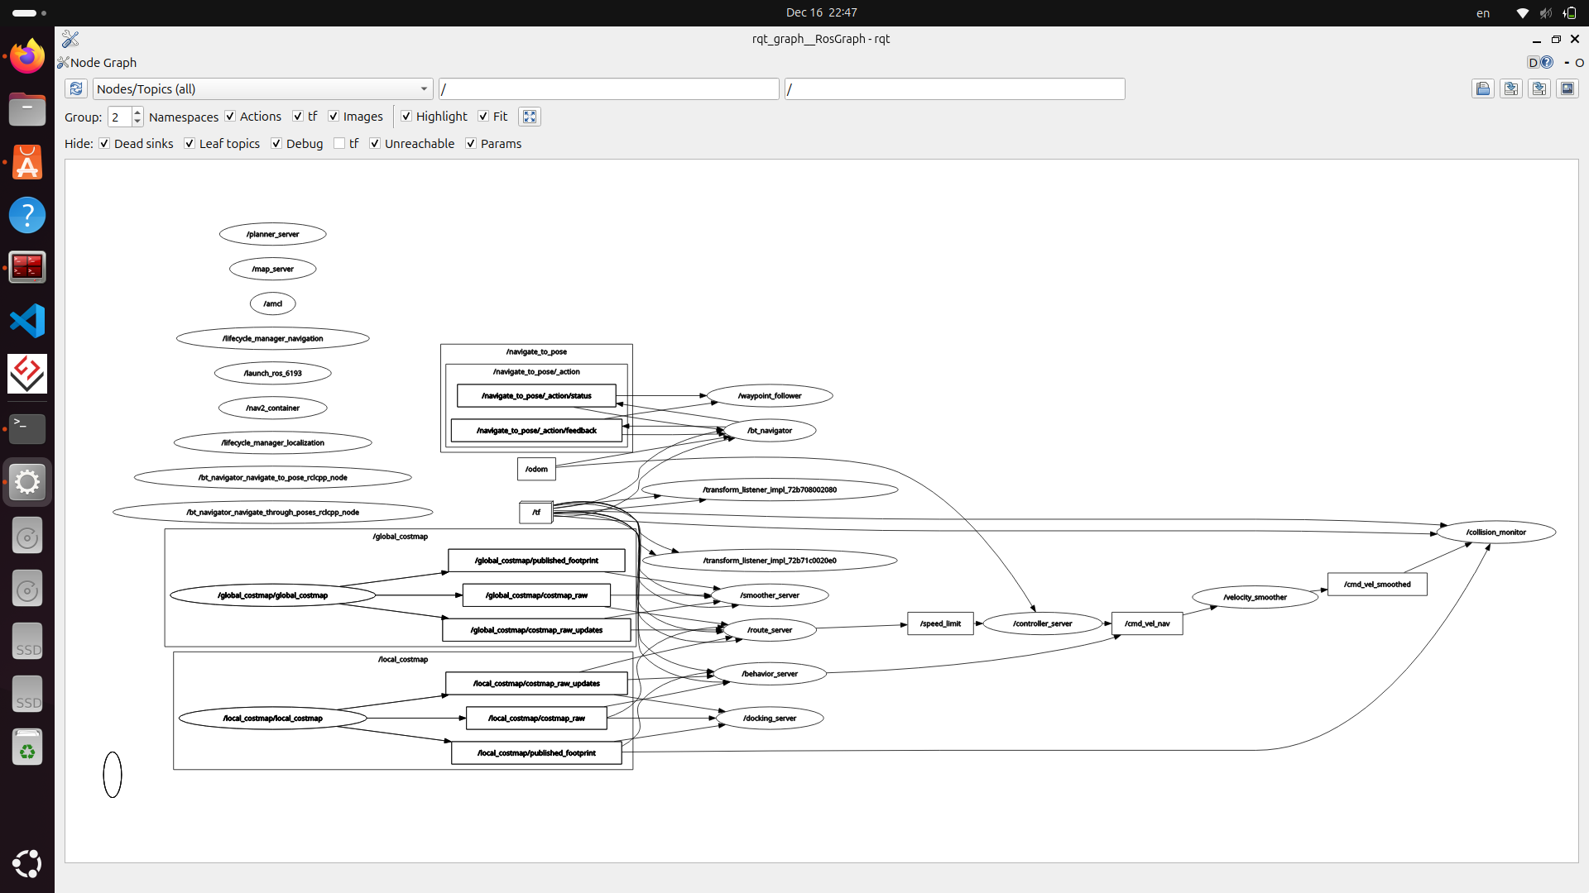

nav2_bringup เป็น package สำหรับ เรียกใช้งาน (bring up) ระบบ Navigation 2 ทั้งชุด
โดยทำหน้าที่รวม launch file, parameter และ configuration ต่าง ๆ
เพื่อให้หุ่นยนต์สามารถ
- วางแผนเส้นทาง (Path Planning)
- หลีกสิ่งกีดขวาง
- เคลื่อนที่ไปยังเป้าหมายอัตโนมัติ

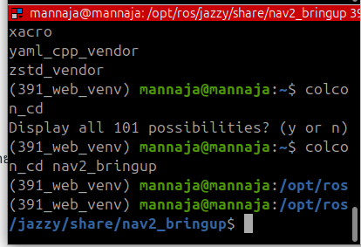

package nav2_bringup อยู่ที่ : /opt/ros/jazzy/share/nav2_bringup
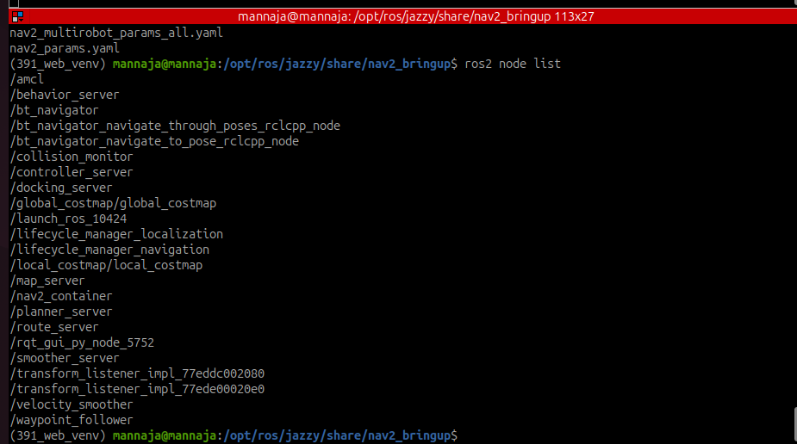
node จะมี
/amcl
/behavior_server
/bt_navigator
/bt_navigator_navigate_through_poses_rclcpp_node
/bt_navigator_navigate_to_pose_rclcpp_node
/collision_monitor
/controller_server
/docking_server
/global_costmap/global_costmap
/launch_ros_10424
/lifecycle_manager_localization
/lifecycle_manager_navigation
/local_costmap/local_costmap
/map_server
/nav2_container
/planner_server
/route_server
/rqt_gui_py_node_5752
/smoother_server
/transform_listener_impl_77eddc002080
/transform_listener_impl_77ede00020e0
/velocity_smoother
/waypoint_follower

nav2_bringup ไม่ได้ประกาศ message ใหม่
แต่ใช้ message มาตรฐาน เช่น:
- geometry_msgs/msg/PoseStamped
- nav_msgs/msg/Path
- nav_msgs/msg/Odometry
- geometry_msgs/msg/Twist
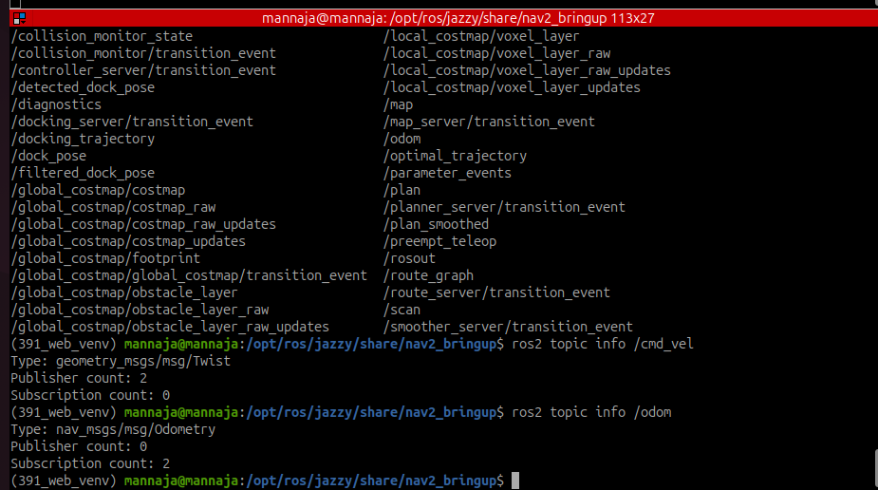
topic ของ nav2_bringup :
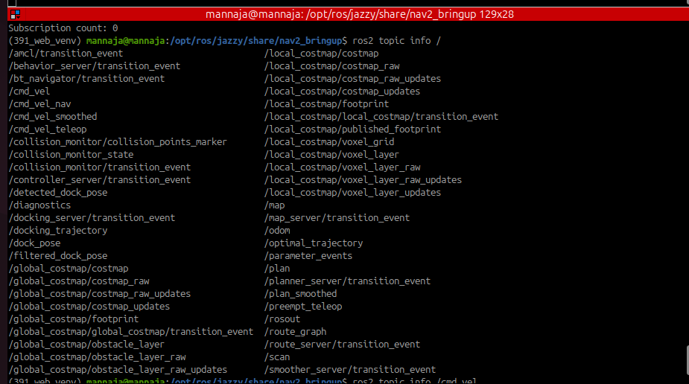

(391_web_venv) mannaja@mannaja:/opt/ros/jazzy/share/nav2_bringup$ ros2 topic info /
/amcl/transition_event /local_costmap/costmap
/behavior_server/transition_event /local_costmap/costmap_raw
/bt_navigator/transition_event /local_costmap/costmap_raw_updates
/cmd_vel /local_costmap/costmap_updates
/cmd_vel_nav /local_costmap/footprint
/cmd_vel_smoothed /local_costmap/local_costmap/transition_event
/cmd_vel_teleop /local_costmap/published_footprint
/collision_monitor/collision_points_marker /local_costmap/voxel_grid
/collision_monitor_state /local_costmap/voxel_layer
/collision_monitor/transition_event /local_costmap/voxel_layer_raw
/controller_server/transition_event /local_costmap/voxel_layer_raw_updates
/detected_dock_pose /local_costmap/voxel_layer_updates
/diagnostics /map
/docking_server/transition_event /map_server/transition_event
/docking_trajectory /odom
/dock_pose /optimal_trajectory
/filtered_dock_pose /parameter_events
/global_costmap/costmap /plan
/global_costmap/costmap_raw /planner_server/transition_event
/global_costmap/costmap_raw_updates /plan_smoothed
/global_costmap/costmap_updates /preempt_teleop
/global_costmap/footprint /rosout
/global_costmap/global_costmap/transition_event /route_graph
/global_costmap/obstacle_layer /route_server/transition_event
/global_costmap/obstacle_layer_raw /scan
/global_costmap/obstacle_layer_raw_updates /smoother_server/transition_event

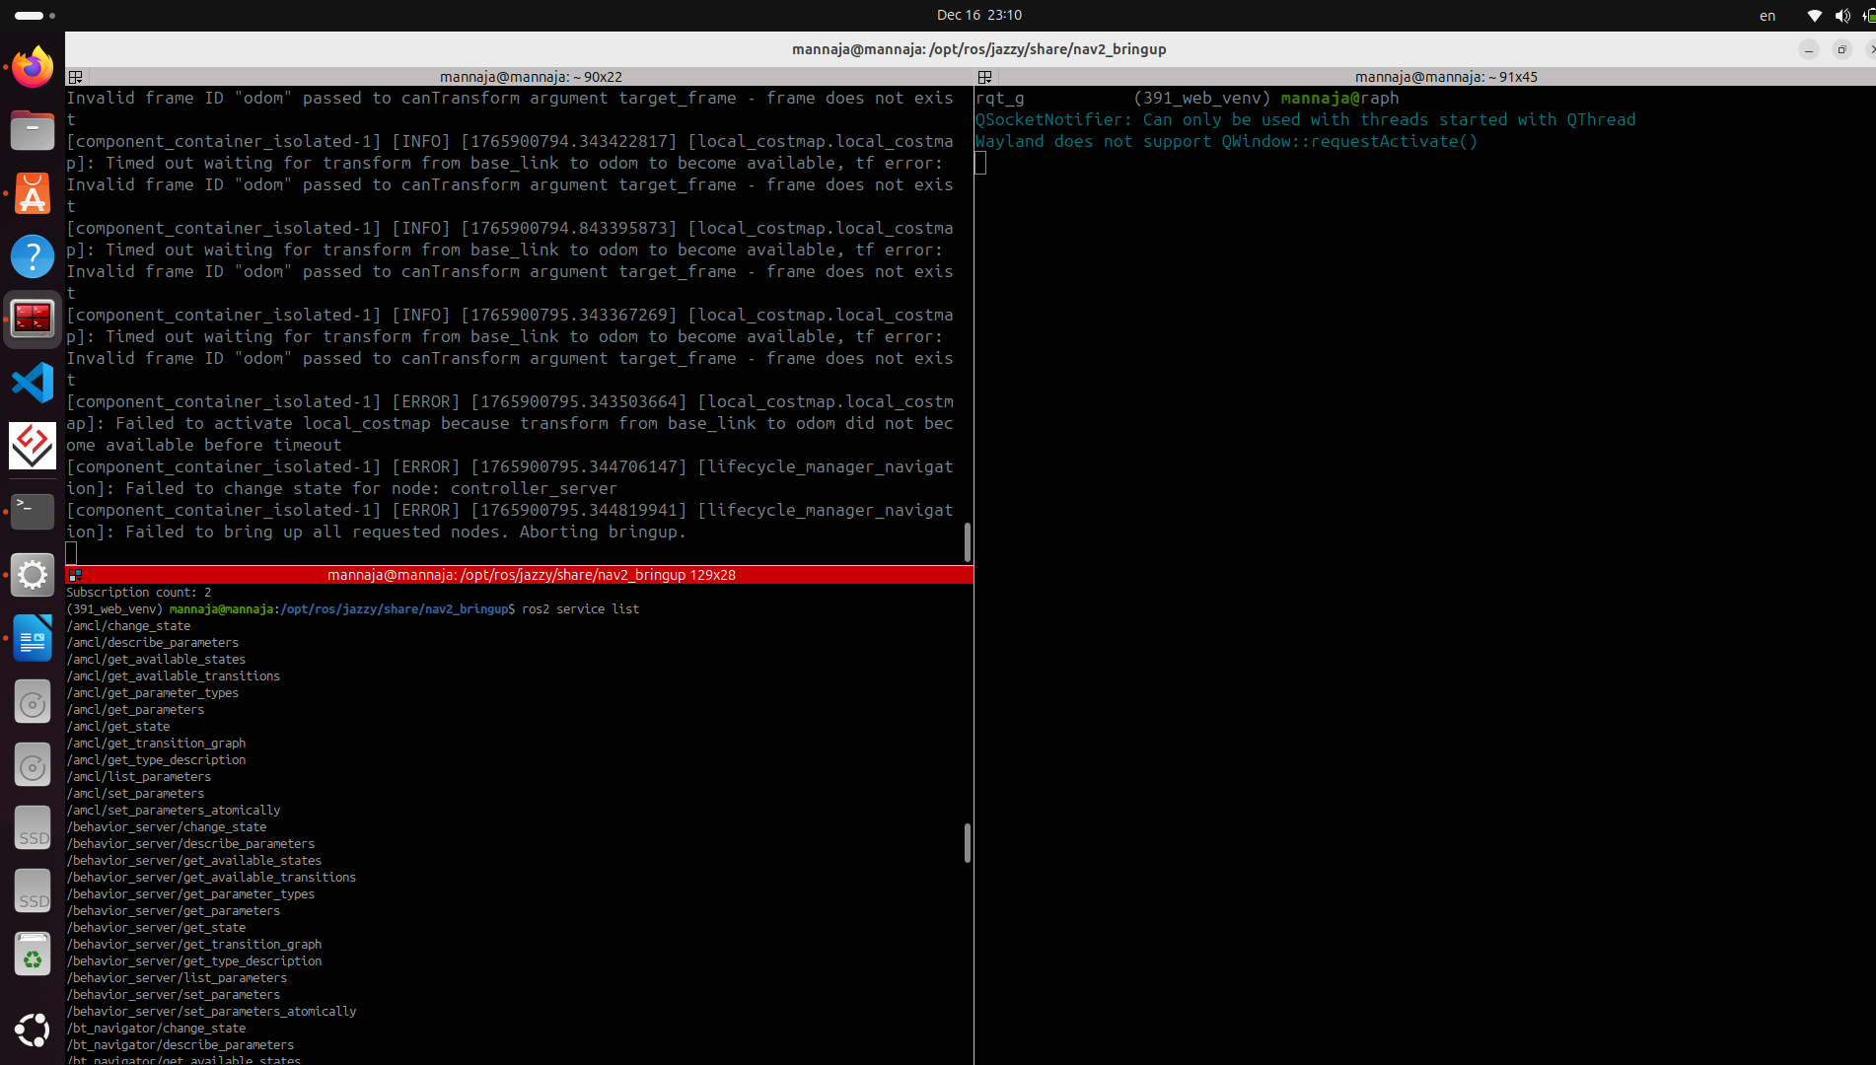
service ของ nav2_bringup :

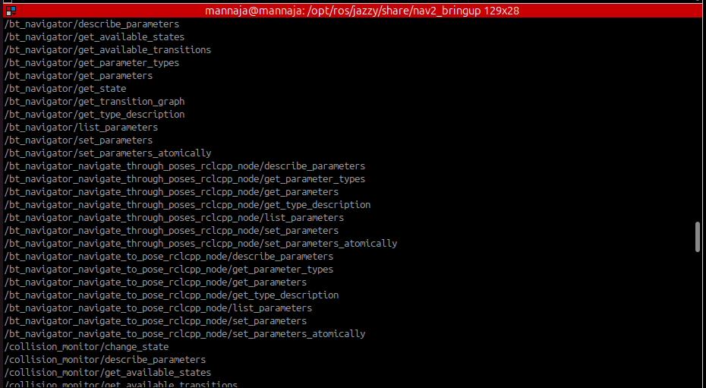

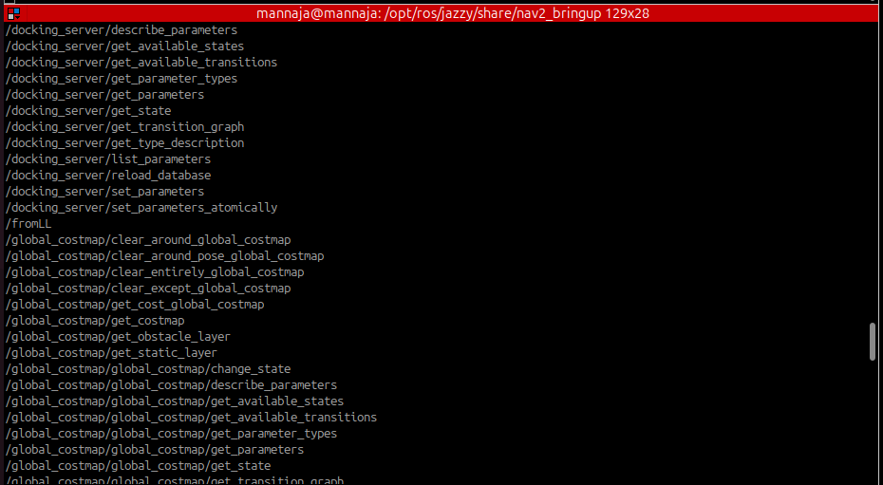

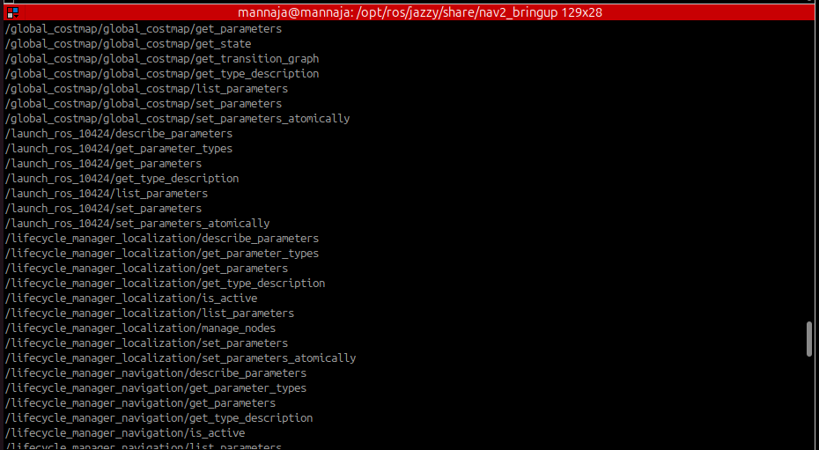

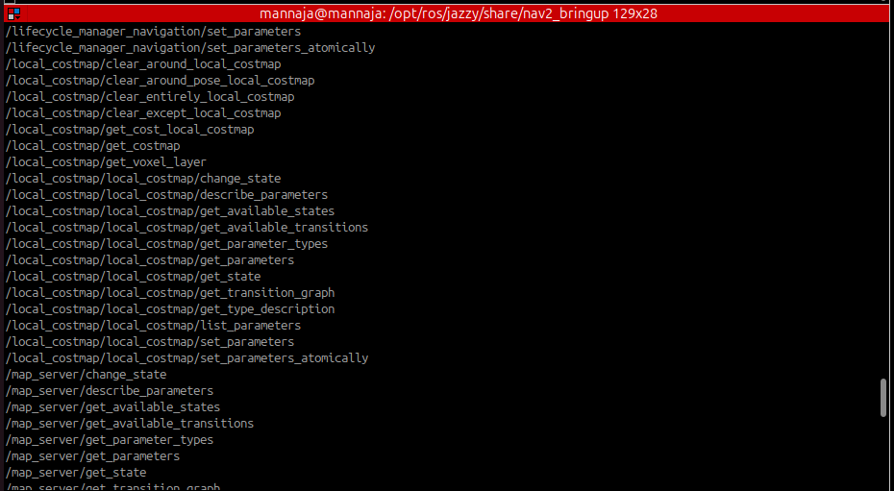

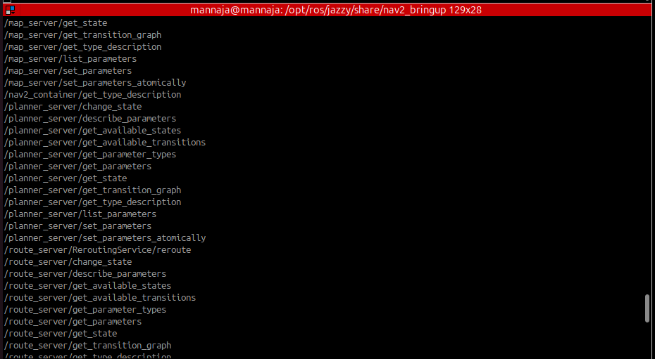

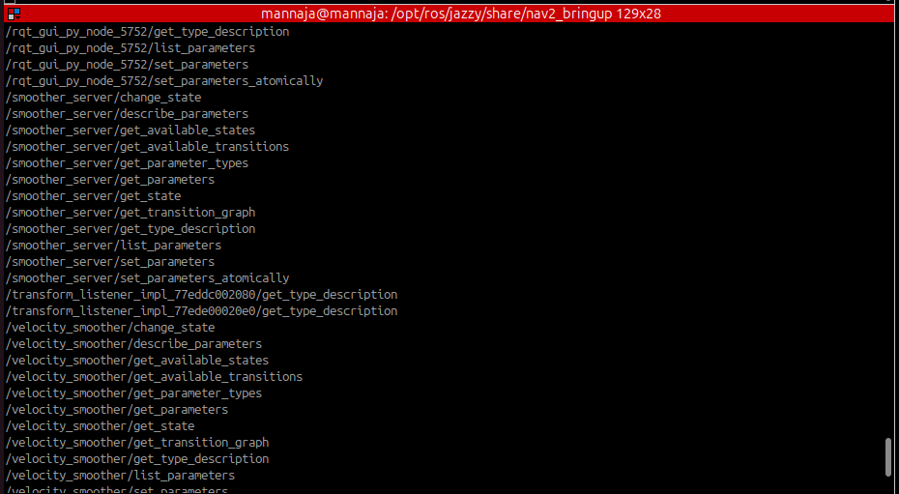

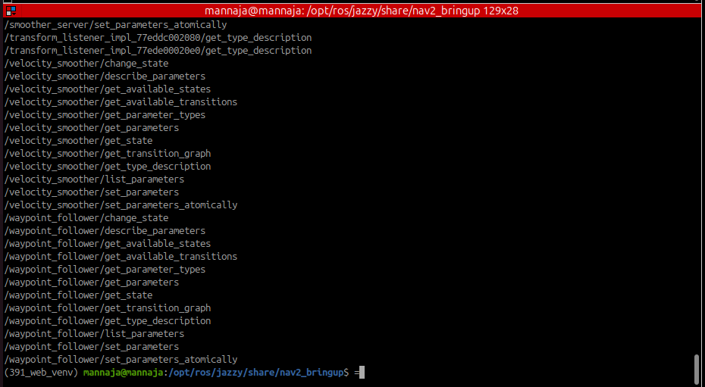

(391_web_venv) mannaja@mannaja:/opt/ros/jazzy/share/nav2_bringup$ ros2 service list
/amcl/change_state
/amcl/describe_parameters
/amcl/get_available_states
/amcl/get_available_transitions
/amcl/get_parameter_types
/amcl/get_parameters
/amcl/get_state
/amcl/get_transition_graph
/amcl/get_type_description
/amcl/list_parameters
/amcl/set_parameters
/amcl/set_parameters_atomically
/behavior_server/change_state
/behavior_server/describe_parameters
/behavior_server/get_available_states
/behavior_server/get_available_transitions
/behavior_server/get_parameter_types
/behavior_server/get_parameters
/behavior_server/get_state
/behavior_server/get_transition_graph
/behavior_server/get_type_description
/behavior_server/list_parameters
/behavior_server/set_parameters
/behavior_server/set_parameters_atomically
/bt_navigator/change_state
/bt_navigator/describe_parameters
/bt_navigator/get_available_states
/bt_navigator/get_available_transitions
/bt_navigator/get_parameter_types
/bt_navigator/get_parameters
/bt_navigator/get_state
/bt_navigator/get_transition_graph
/bt_navigator/get_type_description
/bt_navigator/list_parameters
/bt_navigator/set_parameters
/bt_navigator/set_parameters_atomically
/bt_navigator_navigate_through_poses_rclcpp_node/describe_parameters
/bt_navigator_navigate_through_poses_rclcpp_node/get_parameter_types
/bt_navigator_navigate_through_poses_rclcpp_node/get_parameters
/bt_navigator_navigate_through_poses_rclcpp_node/get_type_description
/bt_navigator_navigate_through_poses_rclcpp_node/list_parameters
/bt_navigator_navigate_through_poses_rclcpp_node/set_parameters
/bt_navigator_navigate_through_poses_rclcpp_node/set_parameters_atomically
/bt_navigator_navigate_to_pose_rclcpp_node/describe_parameters
/bt_navigator_navigate_to_pose_rclcpp_node/get_parameter_types
/bt_navigator_navigate_to_pose_rclcpp_node/get_parameters
/bt_navigator_navigate_to_pose_rclcpp_node/get_type_description
/bt_navigator_navigate_to_pose_rclcpp_node/list_parameters
/bt_navigator_navigate_to_pose_rclcpp_node/set_parameters
/bt_navigator_navigate_to_pose_rclcpp_node/set_parameters_atomically
/collision_monitor/change_state
/collision_monitor/describe_parameters
/collision_monitor/get_available_states
/collision_monitor/get_available_transitions
/collision_monitor/get_parameter_types
/collision_monitor/get_parameters
/collision_monitor/get_state
/collision_monitor/get_transition_graph
/collision_monitor/get_type_description
/collision_monitor/list_parameters
/collision_monitor/set_parameters
/collision_monitor/set_parameters_atomically
/collision_monitor/toggle
/controller_server/change_state
/controller_server/describe_parameters
/controller_server/get_available_states
/controller_server/get_available_transitions
/controller_server/get_parameter_types
/controller_server/get_parameters
/controller_server/get_state
/controller_server/get_transition_graph
/controller_server/get_type_description
/controller_server/list_parameters
/controller_server/set_parameters
/controller_server/set_parameters_atomically
/docking_server/change_state
/docking_server/describe_parameters(391_web_venv) mannaja@mannaja:/opt/ros/jazzy/share/nav2_bringup$ ros2 action list
/assisted_teleop
/backup
/compute_and_track_route
/compute_path_through_poses
/compute_path_to_pose
/compute_route
/dock_robot
/drive_on_heading
/follow_gps_waypoints
/follow_path
/follow_waypoints
/navigate_through_poses
/navigate_to_pose
/smooth_path
/spin
/undock_robot
/wait
/docking_server/get_available_states
/docking_server/get_available_transitions
/docking_server/get_parameter_types
/docking_server/get_parameters
/docking_server/get_state
/docking_server/get_transition_graph
/docking_server/get_type_description
/docking_server/list_parameters
/docking_server/reload_database
/docking_server/set_parameters
/docking_server/set_parameters_atomically
/fromLL
/global_costmap/clear_around_global_costmap
/global_costmap/clear_around_pose_global_costmap
/global_costmap/clear_entirely_global_costmap
/global_costmap/clear_except_global_costmap
/global_costmap/get_cost_global_costmap
/global_costmap/get_costmap
/global_costmap/get_obstacle_layer
/global_costmap/get_static_layer
/global_costmap/global_costmap/change_state
/global_costmap/global_costmap/describe_parameters
/global_costmap/global_costmap/get_available_states
/global_costmap/global_costmap/get_available_transitions
/global_costmap/global_costmap/get_parameter_types
/global_costmap/global_costmap/get_parameters
/global_costmap/global_costmap/get_state
/global_costmap/global_costmap/get_transition_graph
/global_costmap/global_costmap/get_type_description
/global_costmap/global_costmap/list_parameters
/global_costmap/global_costmap/set_parameters
/global_costmap/global_costmap/set_parameters_atomically
/launch_ros_10424/describe_parameters
/launch_ros_10424/get_parameter_types
/launch_ros_10424/get_parameters
/launch_ros_10424/get_type_description
/launch_ros_10424/list_parameters
/launch_ros_10424/set_parameters
/launch_ros_10424/set_parameters_atomically
/lifecycle_manager_localization/describe_parameters
/lifecycle_manager_localization/get_parameter_types
/lifecycle_manager_localization/get_parameters
/lifecycle_manager_localization/get_type_description
/lifecycle_manager_localization/is_active
/lifecycle_manager_localization/list_parameters
/lifecycle_manager_localization/manage_nodes
/lifecycle_manager_localization/set_parameters
/lifecycle_manager_localization/set_parameters_atomically
/lifecycle_manager_navigation/describe_parameters
/lifecycle_manager_navigation/get_parameter_types
/lifecycle_manager_navigation/get_parameters
/lifecycle_manager_navigation/get_type_description
/lifecycle_manager_navigation/is_active
/lifecycle_manager_navigation/list_parameters
/lifecycle_manager_navigation/manage_nodes
/lifecycle_manager_navigation/set_parameters
/lifecycle_manager_navigation/set_parameters_atomically
/local_costmap/clear_around_local_costmap
/local_costmap/clear_around_pose_local_costmap
/local_costmap/clear_entirely_local_costmap
/local_costmap/clear_except_local_costmap
/local_costmap/get_cost_local_costmap
/local_costmap/get_costmap
/local_costmap/get_voxel_layer
/local_costmap/local_costmap/change_state
/local_costmap/local_costmap/describe_parameters
/local_costmap/local_costmap/get_available_states
/local_costmap/local_costmap/get_available_transitions
/local_costmap/local_costmap/get_parameter_types
/local_costmap/local_costmap/get_parameters
/local_costmap/local_costmap/get_state
/local_costmap/local_costmap/get_transition_graph
/local_costmap/local_costmap/get_type_description
/local_costmap/local_costmap/list_parameters
/local_costmap/local_costmap/set_parameters
/local_costmap/local_costmap/set_parameters_atomically
/map_server/change_state
/map_server/describe_parameters
/map_server/get_available_states
/map_server/get_available_transitions
/map_server/get_parameter_types
/map_server/get_parameters
/map_server/get_state
/map_server/get_transition_graph
/map_server/get_type_description
/map_server/list_parameters
/map_server/set_parameters
/map_server/set_parameters_atomically
/nav2_container/get_type_description
/planner_server/change_state
/planner_server/describe_parameters
/planner_server/get_available_states
/planner_server/get_available_transitions
/planner_server/get_parameter_types
/planner_server/get_parameters
/planner_server/get_state
/planner_server/get_transition_graph
/planner_server/get_type_description
/planner_server/list_parameters
/planner_server/set_parameters
/planner_server/set_parameters_atomically
/route_server/ReroutingService/reroute
/route_server/change_state
/route_server/describe_parameters
/route_server/get_available_states
/route_server/get_available_transitions
/route_server/get_parameter_types
/route_server/get_parameters
/route_server/get_state
/route_server/get_transition_graph
/route_server/get_type_description
/route_server/list_parameters
/route_server/set_parameters
/route_server/set_parameters_atomically
/route_server/set_route_graph
/rqt_gui_py_node_5752/describe_parameters
/rqt_gui_py_node_5752/get_parameter_types
/rqt_gui_py_node_5752/get_parameters
/rqt_gui_py_node_5752/get_type_description
/rqt_gui_py_node_5752/list_parameters
/rqt_gui_py_node_5752/set_parameters
/rqt_gui_py_node_5752/set_parameters_atomically
/smoother_server/change_state
/smoother_server/describe_parameters
/smoother_server/get_available_states
/smoother_server/get_available_transitions
/smoother_server/get_parameter_types
/smoother_server/get_parameters
/smoother_server/get_state
/smoother_server/get_transition_graph
/smoother_server/get_type_description
/smoother_server/list_parameters
/smoother_server/set_parameters
/smoother_server/set_parameters_atomically
/transform_listener_impl_77eddc002080/get_type_description
/transform_listener_impl_77ede00020e0/get_type_description
/velocity_smoother/change_state
/velocity_smoother/describe_parameters
/velocity_smoother/get_available_states
/velocity_smoother/get_available_transitions
/velocity_smoother/get_parameter_types
/velocity_smoother/get_parameters
/velocity_smoother/get_state
/velocity_smoother/get_transition_graph
/velocity_smoother/get_type_description
/velocity_smoother/list_parameters
/velocity_smoother/set_parameters
/velocity_smoother/set_parameters_atomically
/waypoint_follower/change_state
/waypoint_follower/describe_parameters
/waypoint_follower/get_available_states
/waypoint_follower/get_available_transitions
/waypoint_follower/get_parameter_types
/waypoint_follower/get_parameters
/waypoint_follower/get_state
/waypoint_follower/get_transition_graph
/waypoint_follower/get_type_description
/waypoint_follower/list_parameters
/waypoint_follower/set_parameters
/waypoint_follower/set_parameters_atomically

action ของ : nav2_bringup

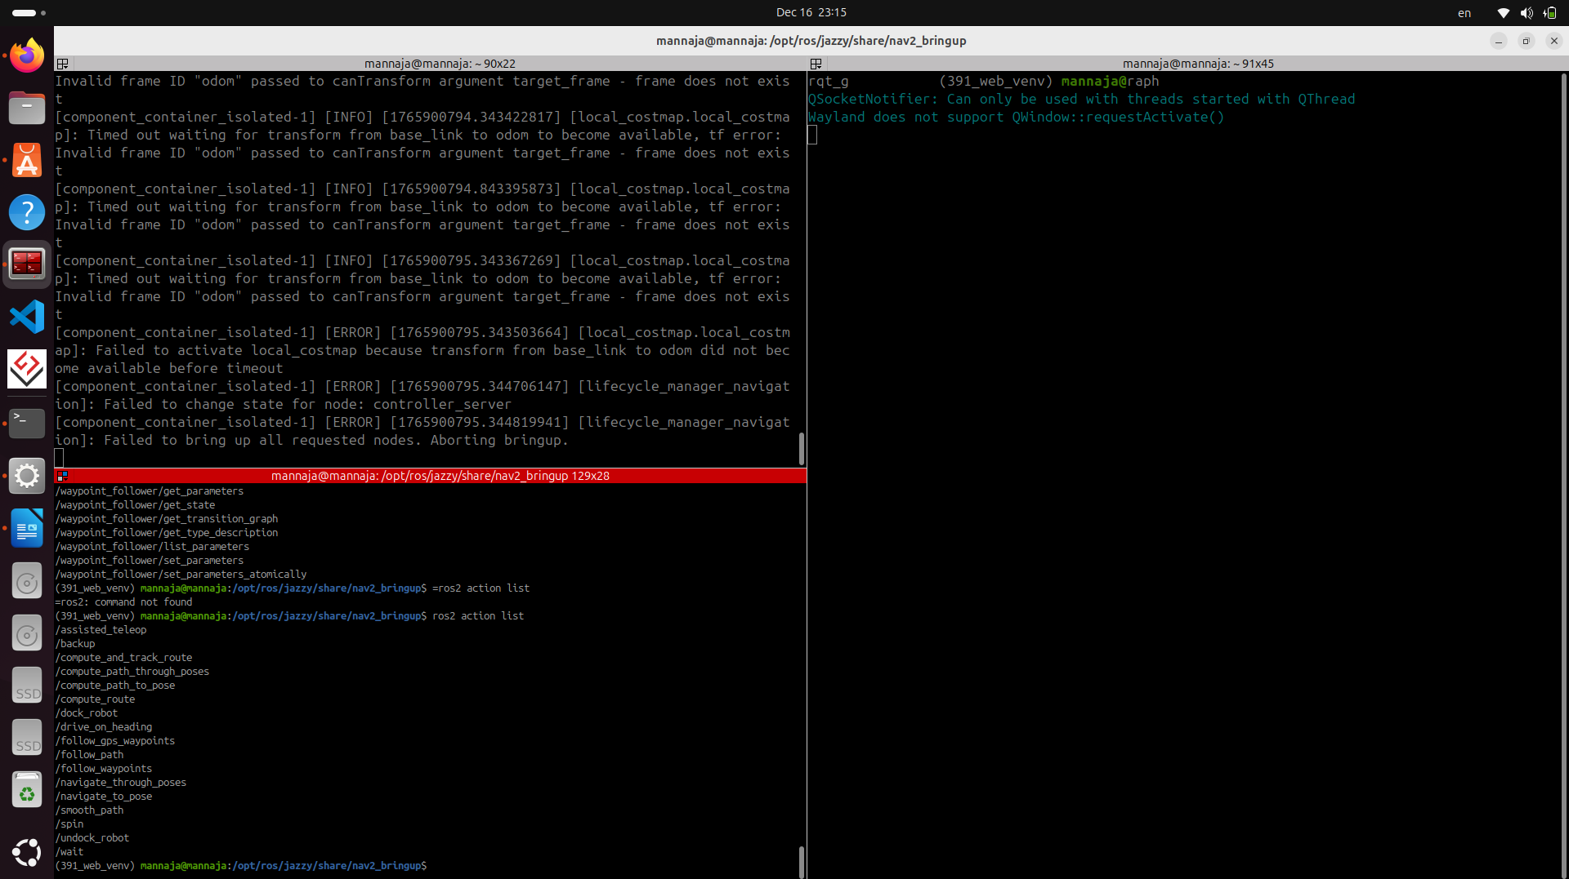

(391_web_venv) mannaja@mannaja:/opt/ros/jazzy/share/nav2_bringup$ ros2 action list
/assisted_teleop
/backup
/compute_and_track_route
/compute_path_through_poses
/compute_path_to_pose
/compute_route
/dock_robot
/drive_on_heading
/follow_gps_waypoints
/follow_path
/follow_waypoints
/navigate_through_poses
/navigate_to_pose
/smooth_path
/spin
/undock_robot
/wait

etc. (Launch & Parameter)
- ใช้ Python launch file
- ใช้ parameter จากไฟล์ .yaml
- รองรับ use_sim_time
- สามารถปรับ planner, controller ได้จาก config
ให้ลองรัน turtle_sim พร้อม teleop_twist_keyboard
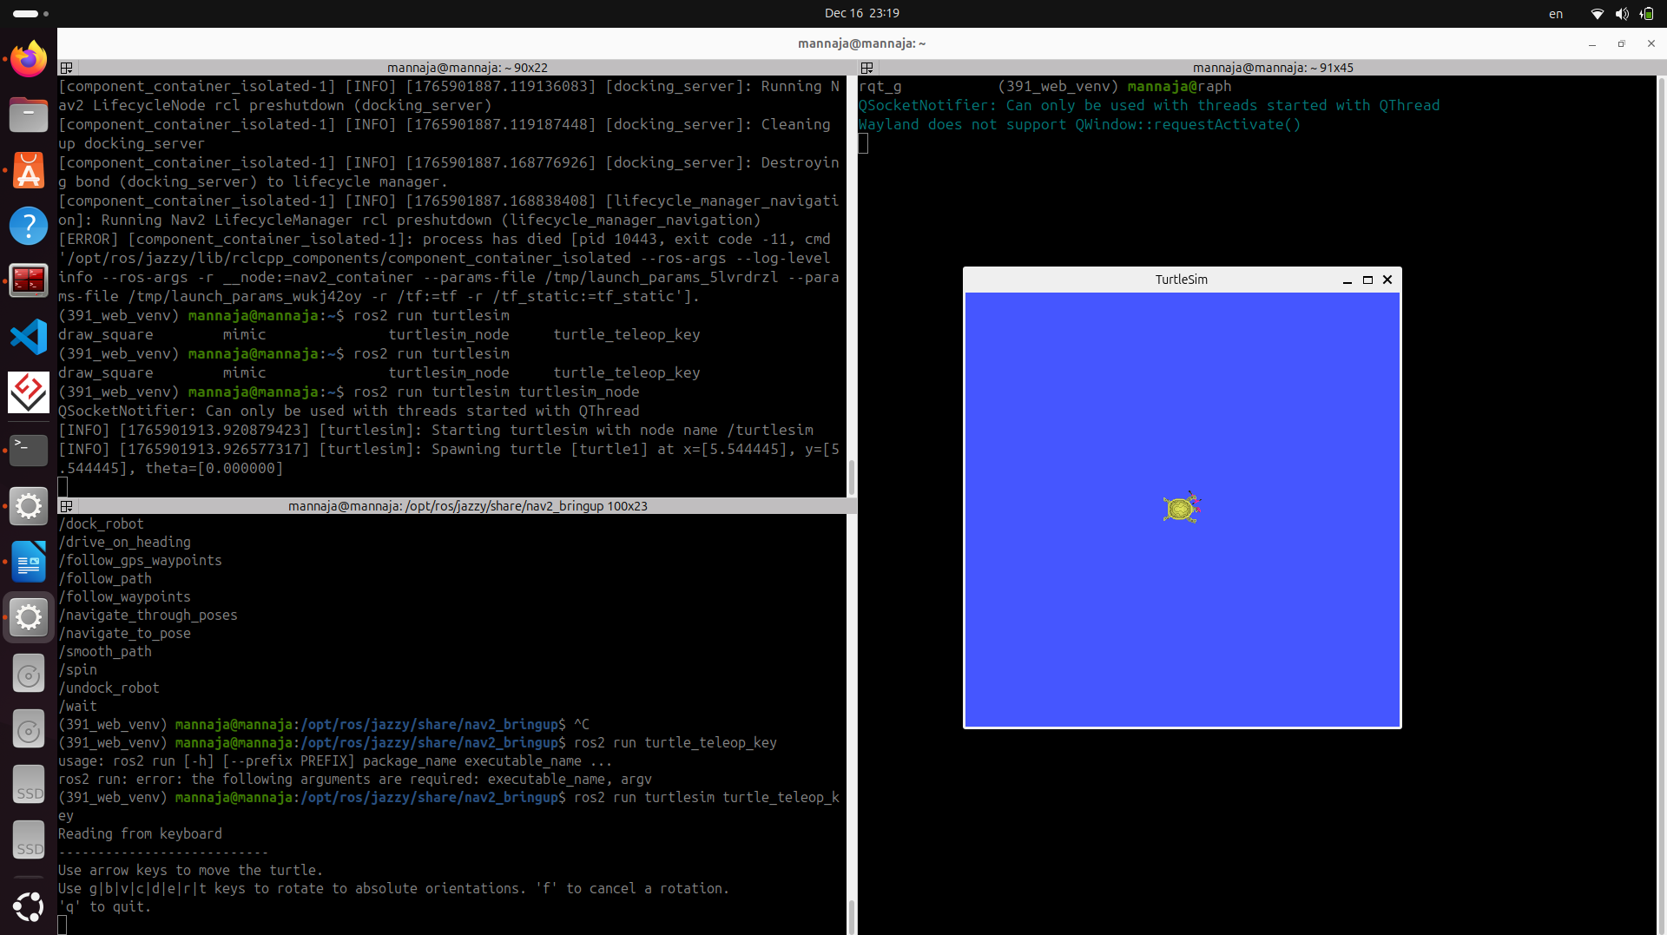
rqt_graph :

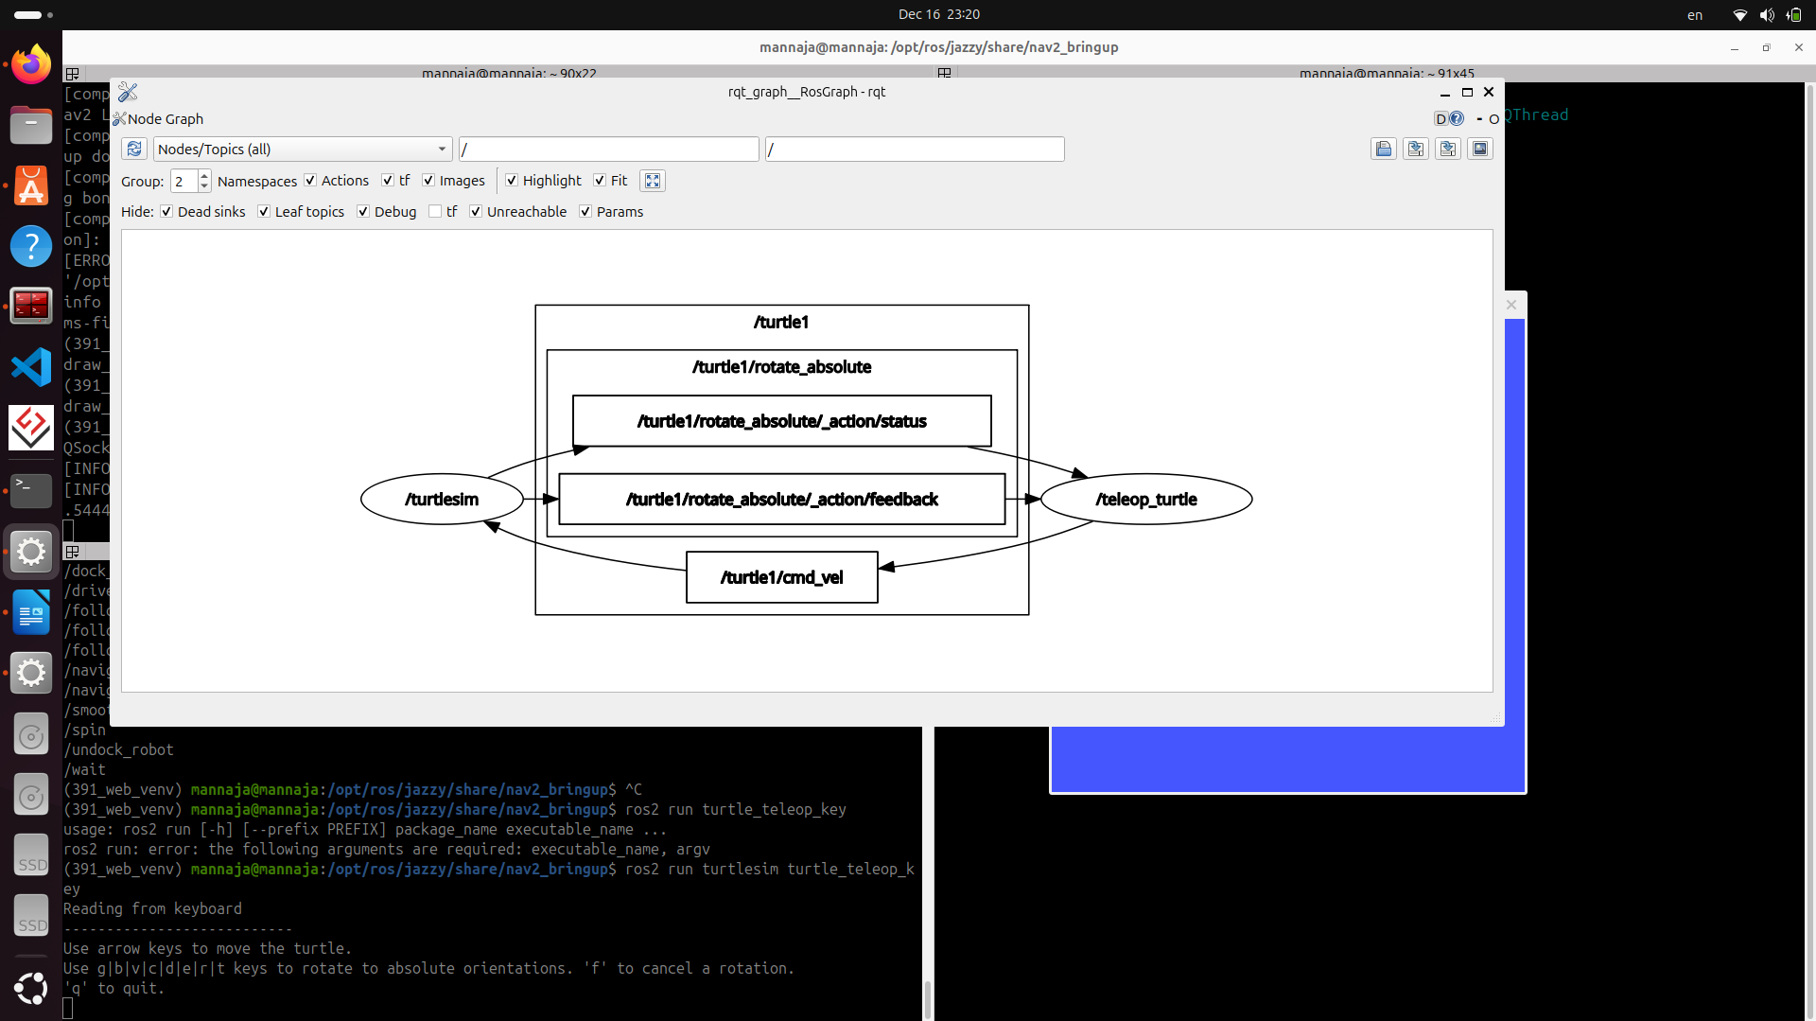

ใช้ปุ่ม ลูกศร เพื่อเดินไปด้านต่างๆ โดย
ลูกศรขึ้น คือ เดินหน้า
ลูกศรลง คือ ถอยหลัง
ลูกศรซ้าย คือ เลี้ยวซ้าย
ลูกศรขวา คือ เลี้ยวขวา
g b v c d e r t → หมุนเต่าไปทิศทางที่กำหนดไว้ล่วงหน้า
f → ยกเลิกคำสั่งหมุน / เดิน
q → ออก

node ที่ใช้ :
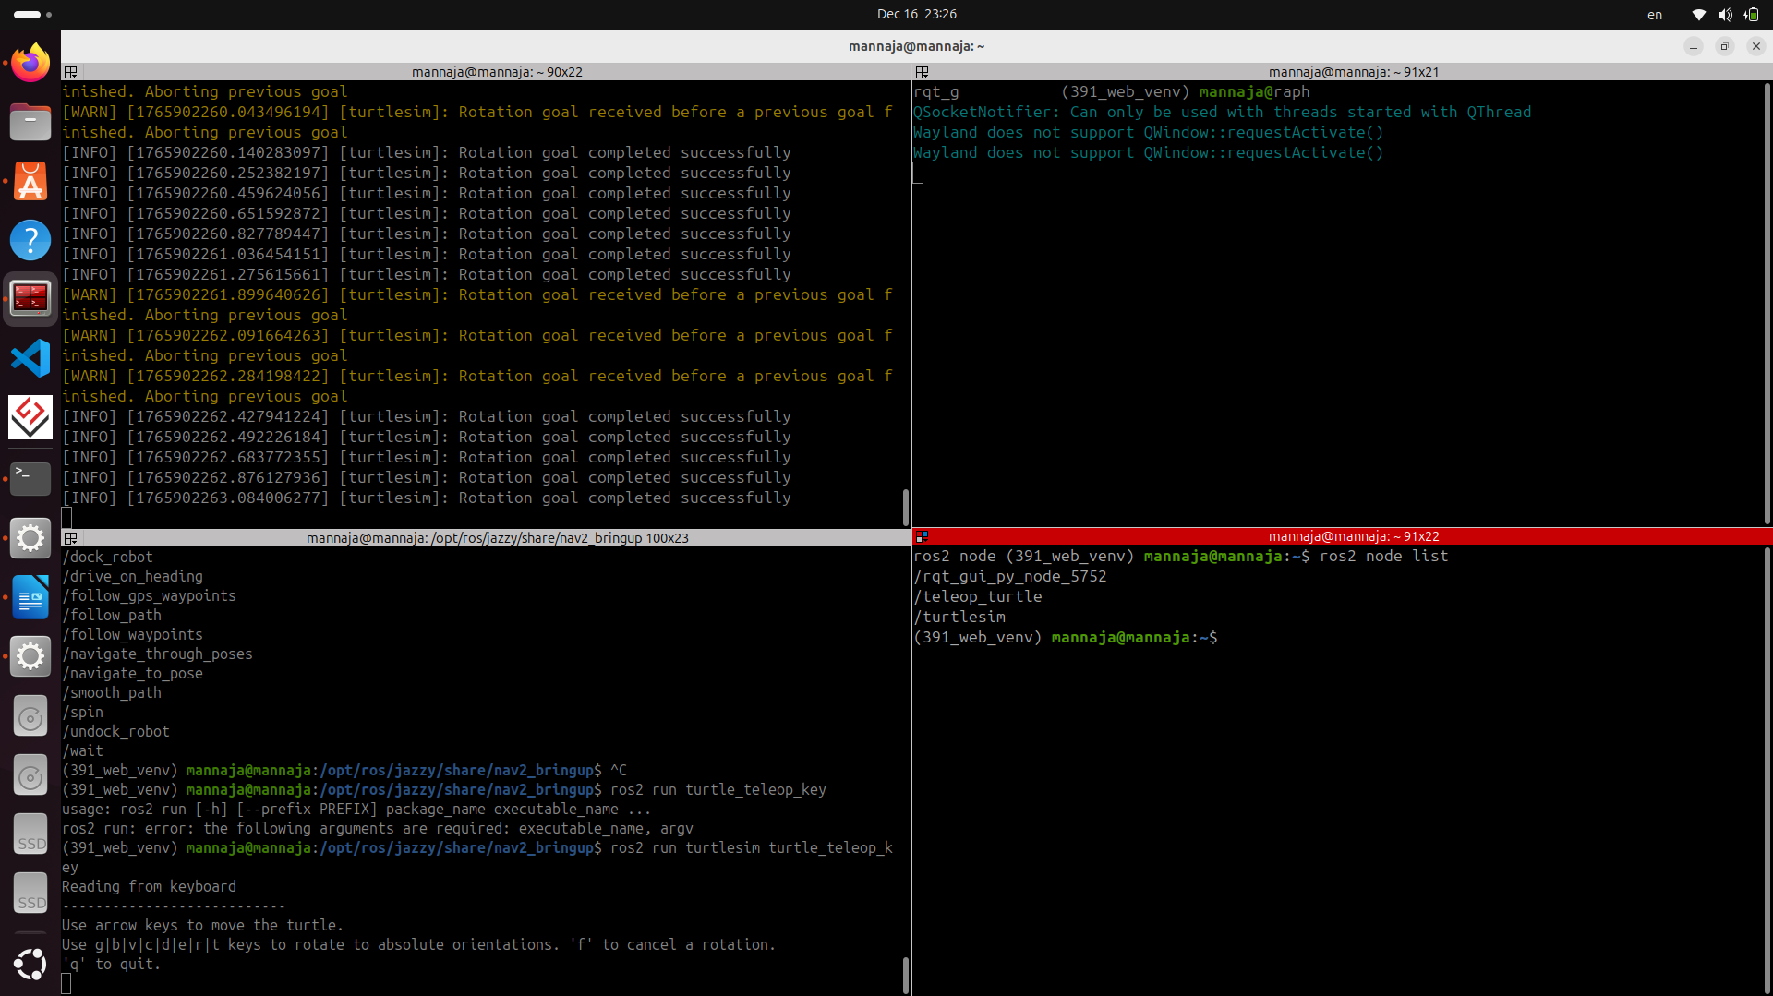
/teleop_turtle
/turtlesim

teleop_turtle คือ ไว้สำหรับคุมการเคลื่อนที่ของเต่า
turtlesim คือ node แสดงผลของเต่า

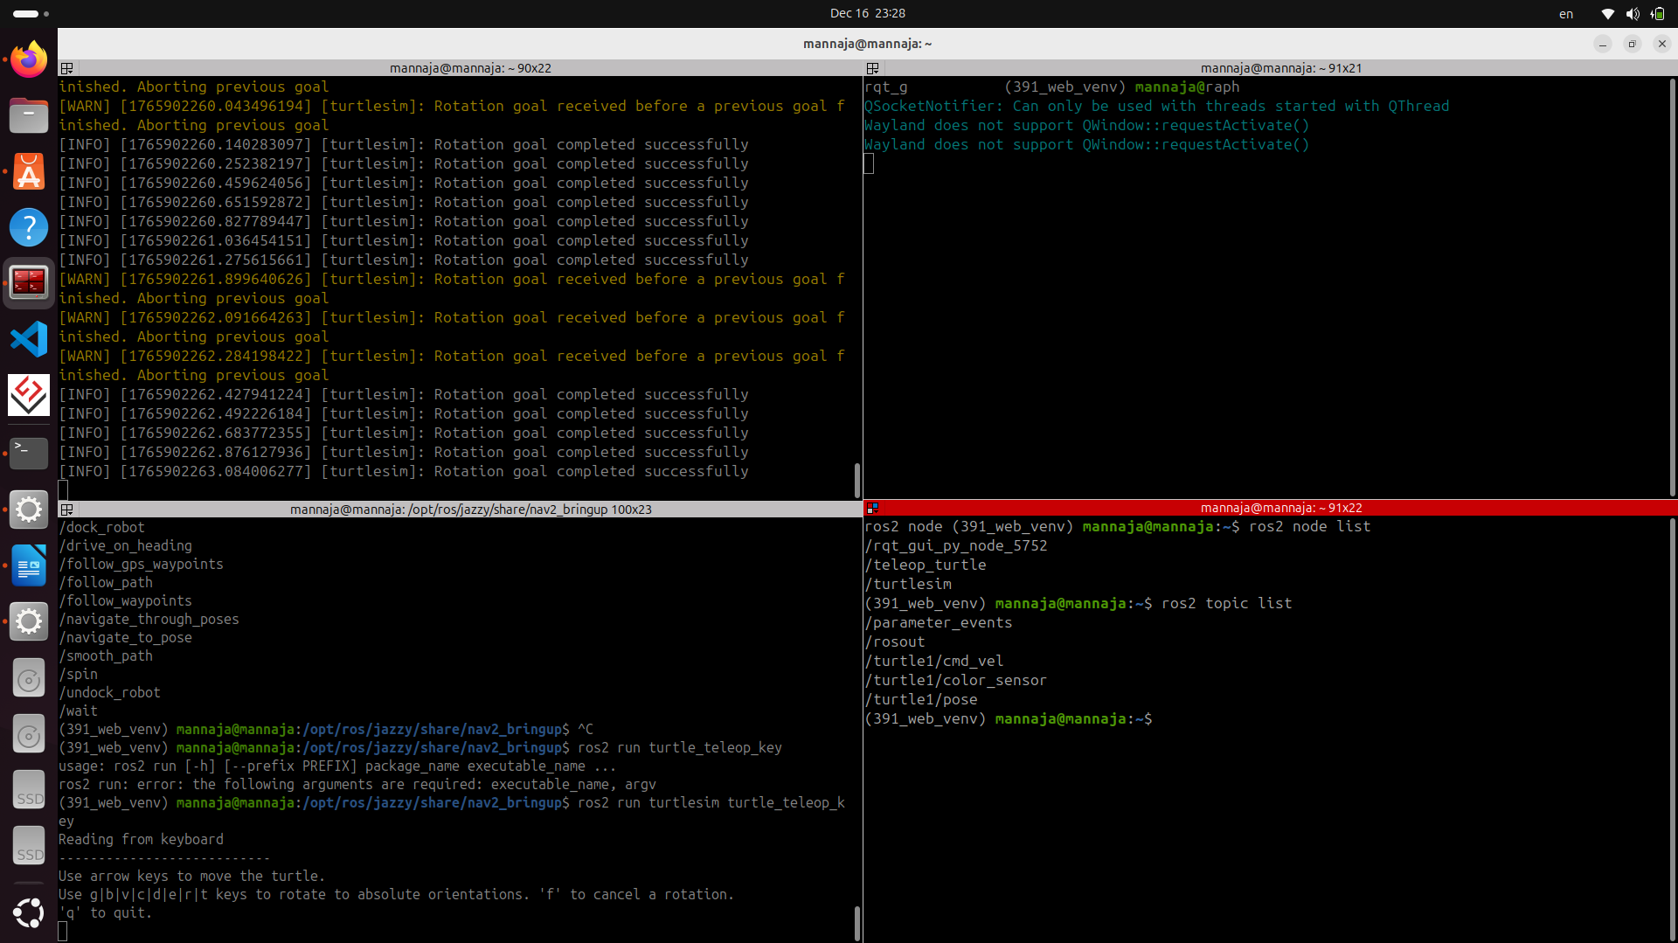
topic ที่ใช้ :

/turtle1/cmd_vel
/turtle1/color_sensor
/turtle1/pose

turtle1/cmd_vel คือ topic สำหรับการส่งความเร็วต่างๆ ของเต่า
turtle1/color_sensor คือ topic สำหรับสีต่างๆ ของเต่า และพื้นหลังของเต่า
turtle1/pose คือ topic สำหรับแสดงผลว่าเต่าอยู่ที่ตำแหน่งที่เท่าไหร่ของจอ

